Task on CloudFront & Route 53
1.Configure VPC peering in cross regions.
- Created a vpc with 2 subnets
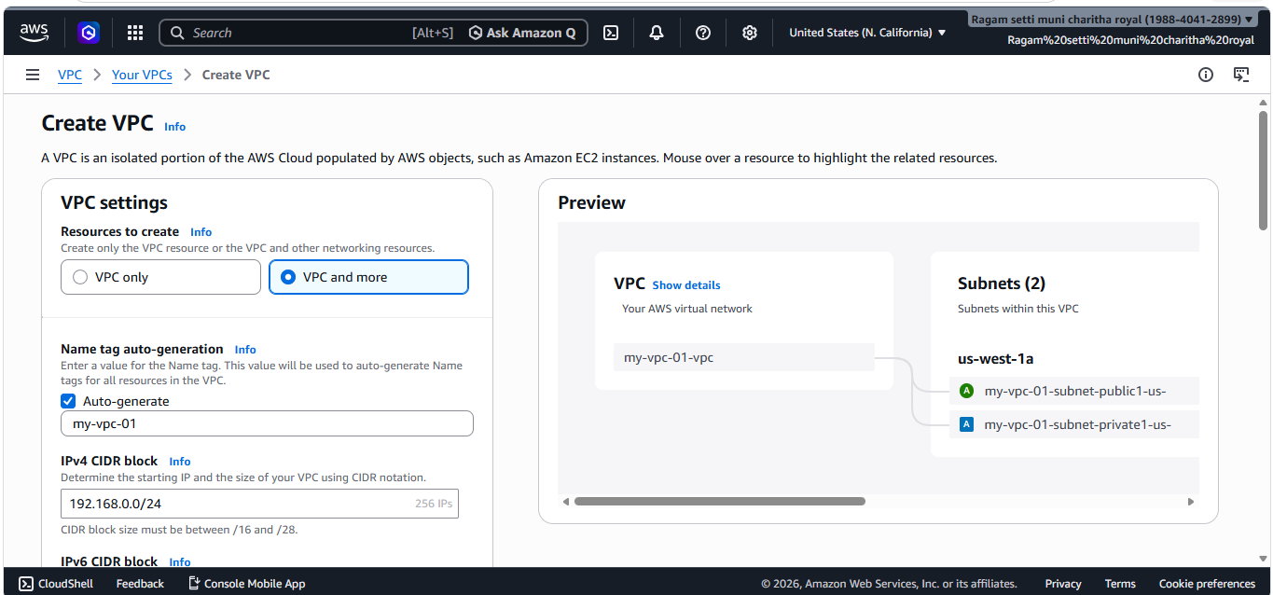
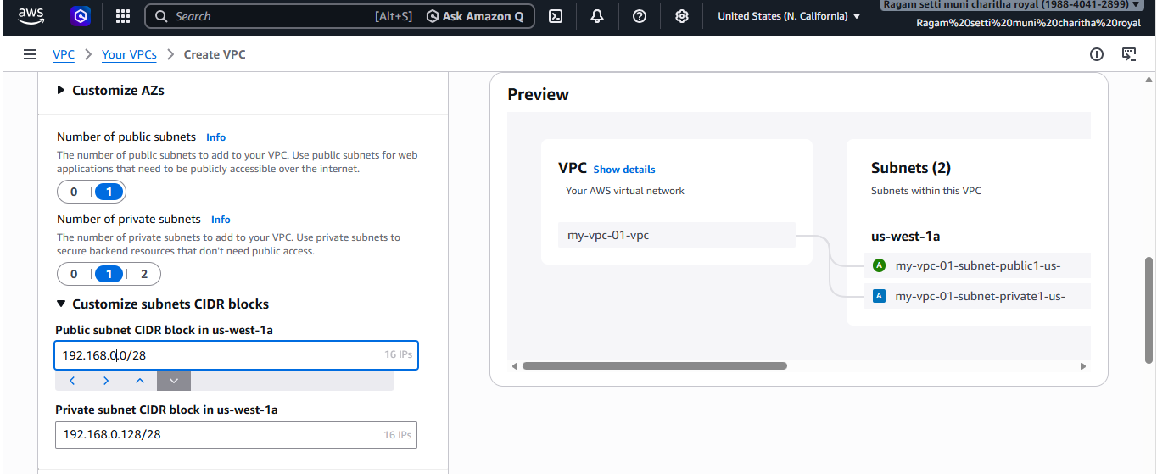
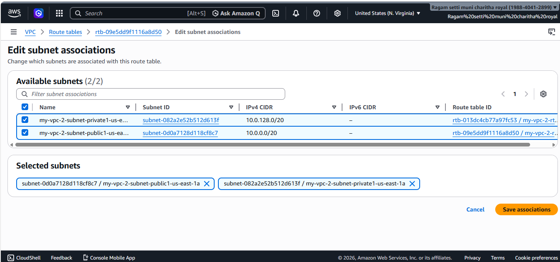
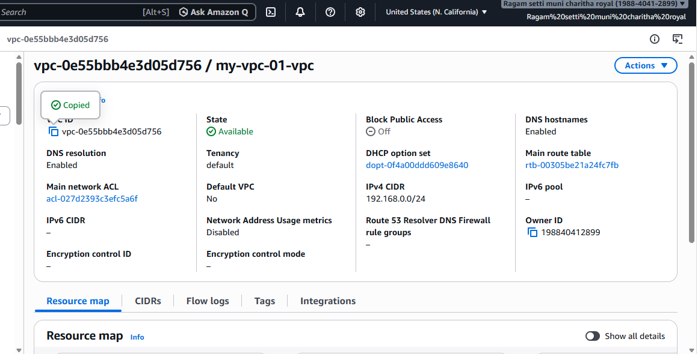
- Creating a peering connection in same account but different regions.
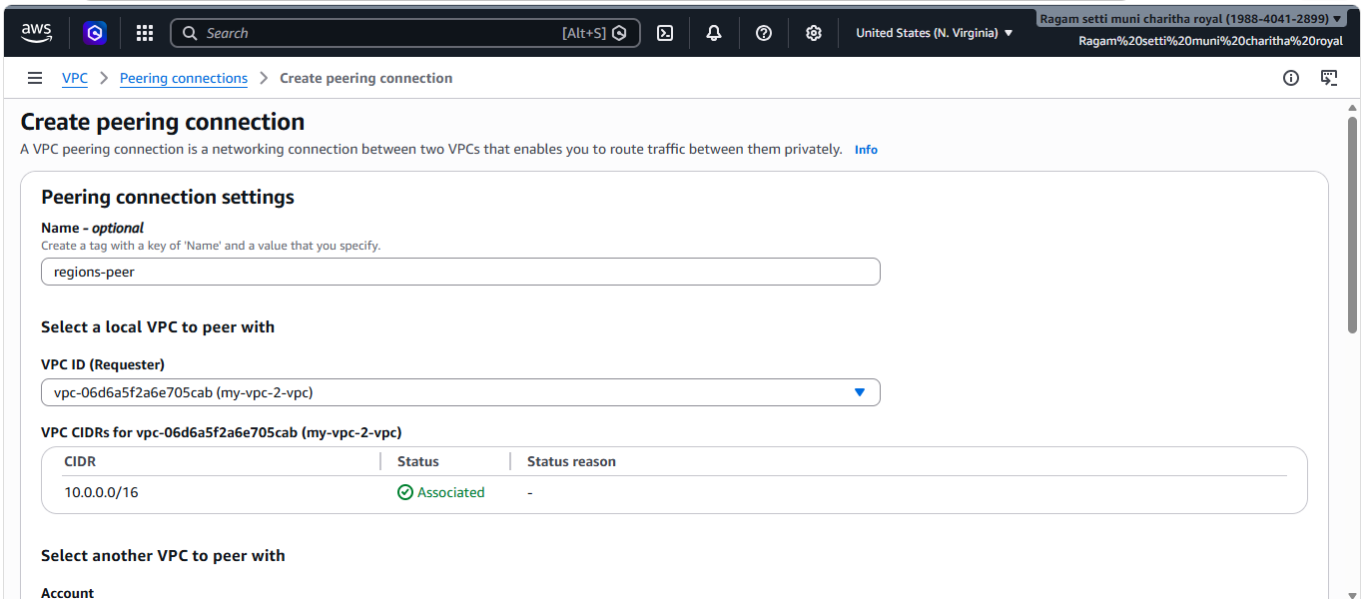
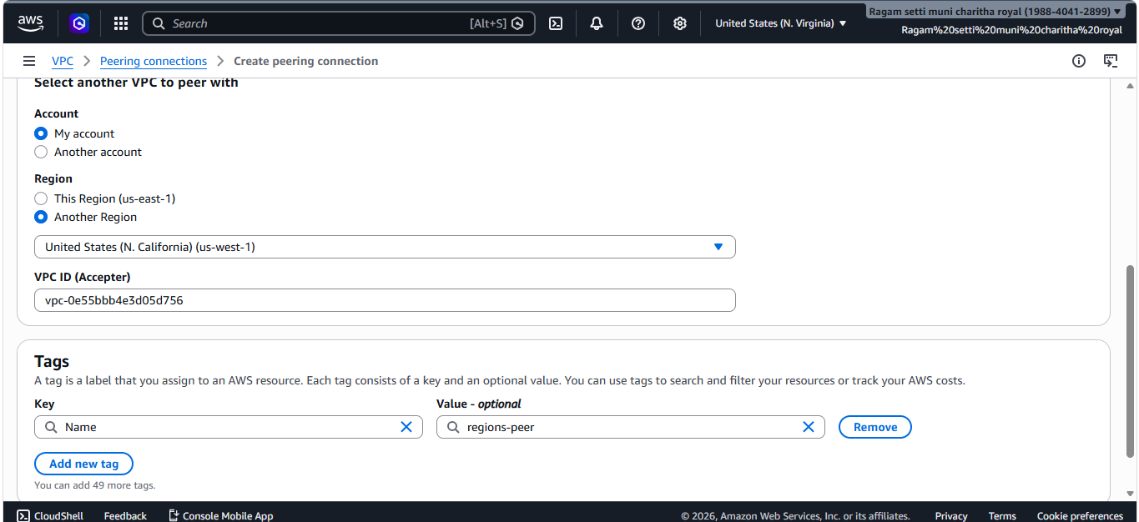
- After sending request accepted the peering request
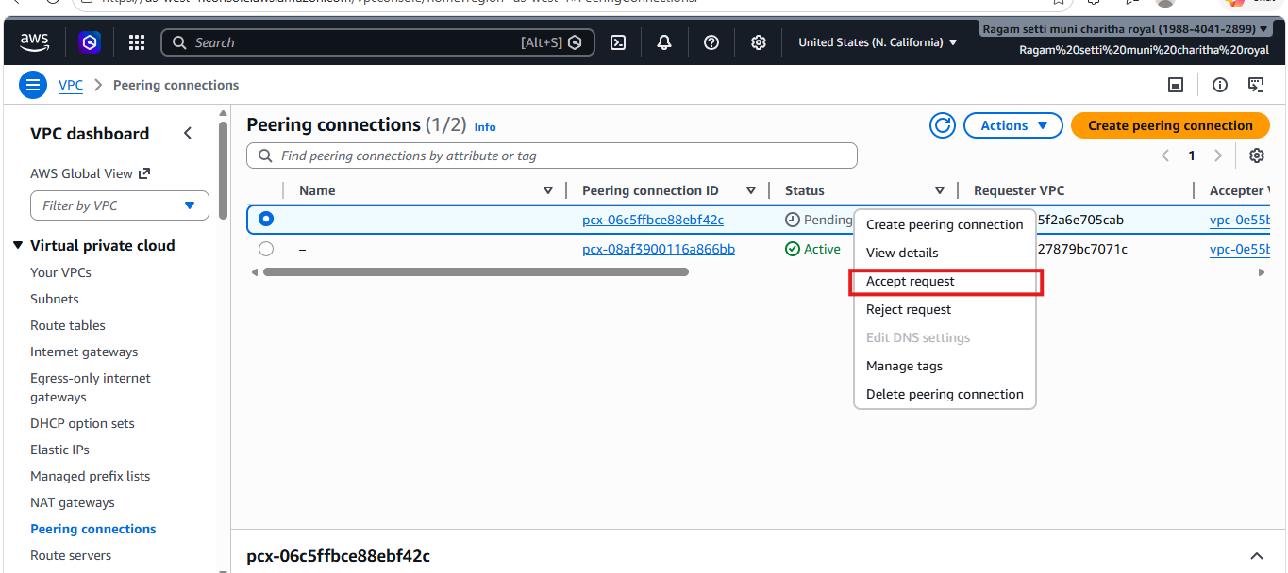
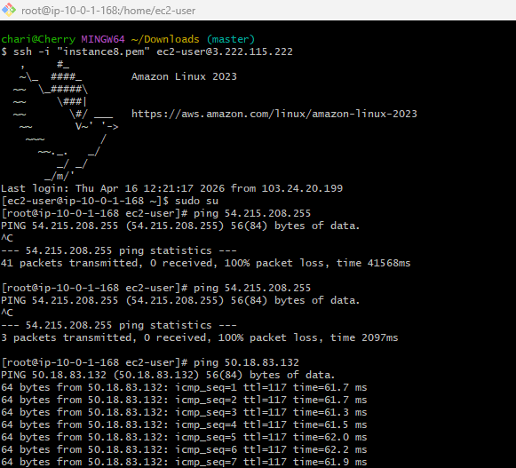

2.Purchase one domain from GoDaddy.
- Purchased one domain successfully from GoDaddy
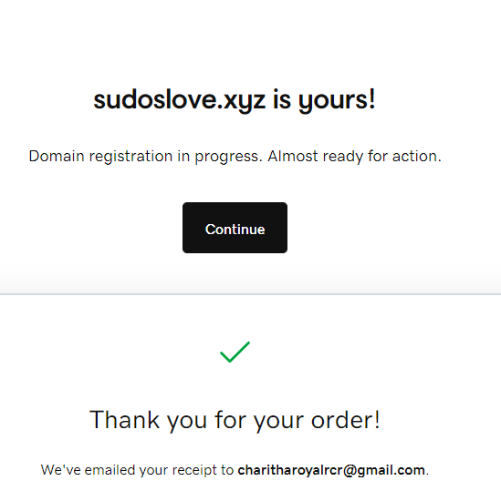

3. Deploy static website in S3.
- Created a new bucket with the name mydemo-bucket-14 and gave public access.
- And uploaded the files I created

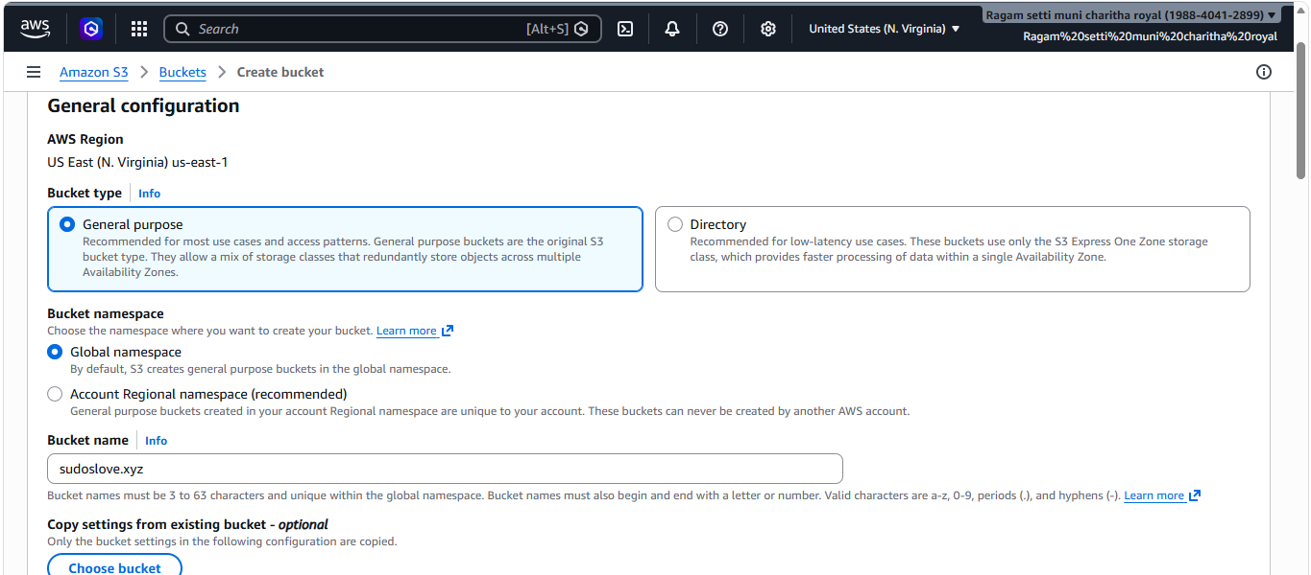
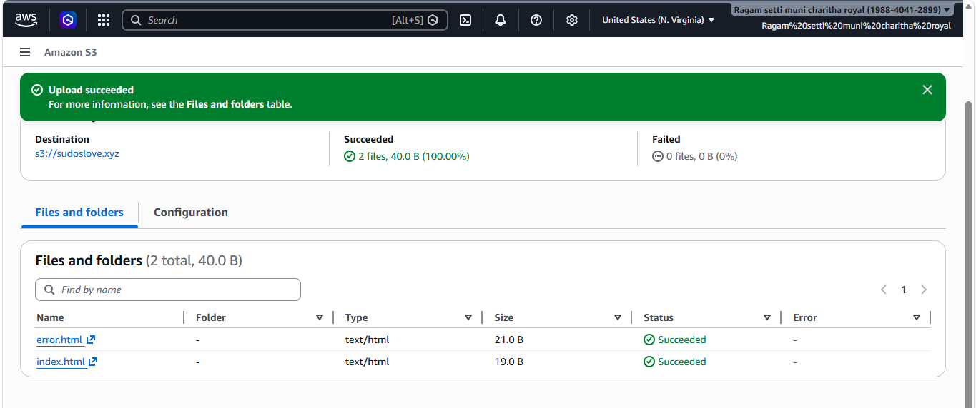
- Added bucket policy to allow

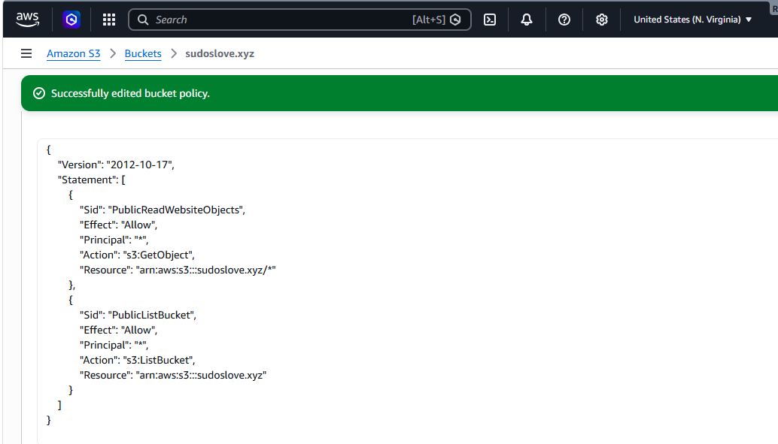
- Now I have enabled static website hosting
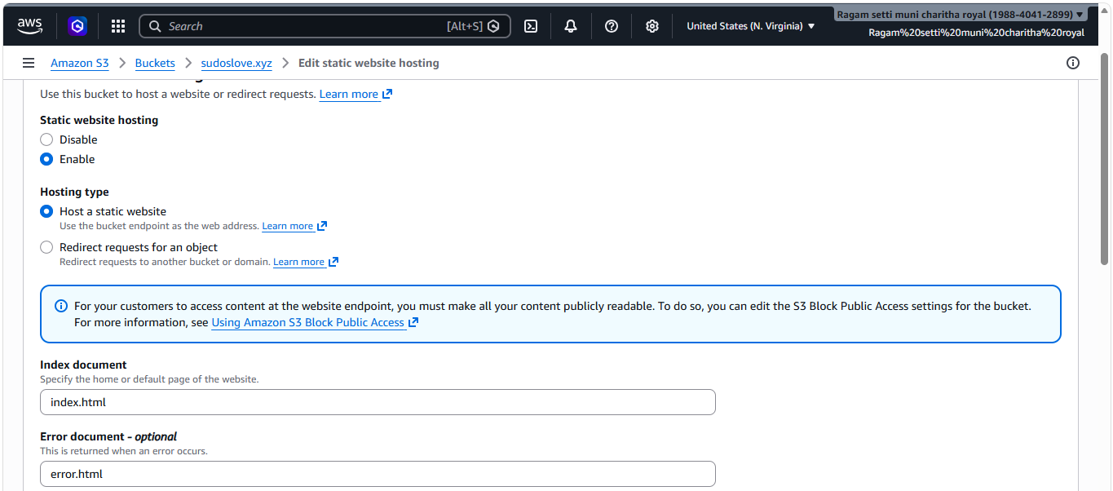
- I have copied the bucket website endpoint and tried to access that in web
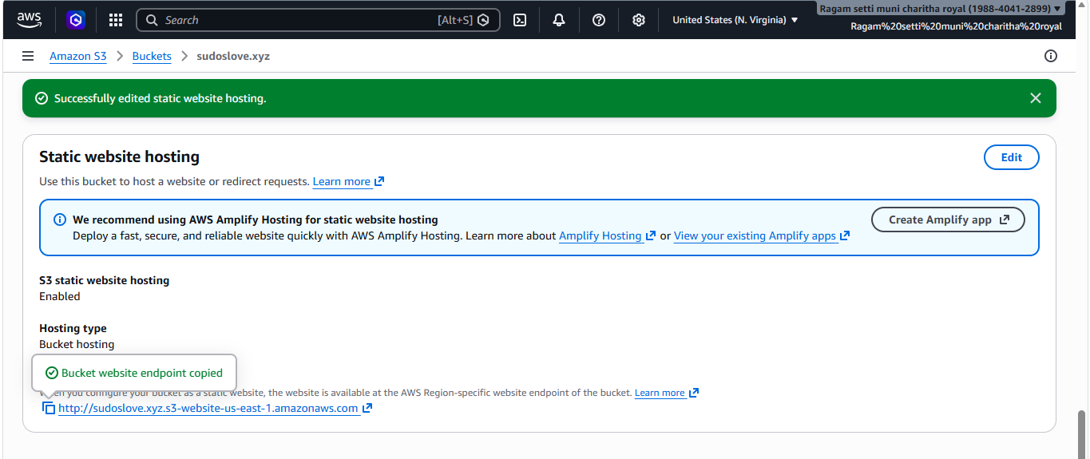
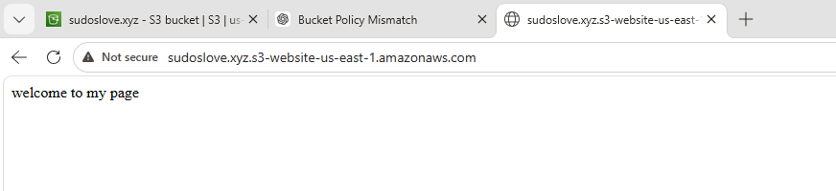

4. Create a CDN and attach one SSL certificate.
- Requested a certificate with *.sudoslove.xyz
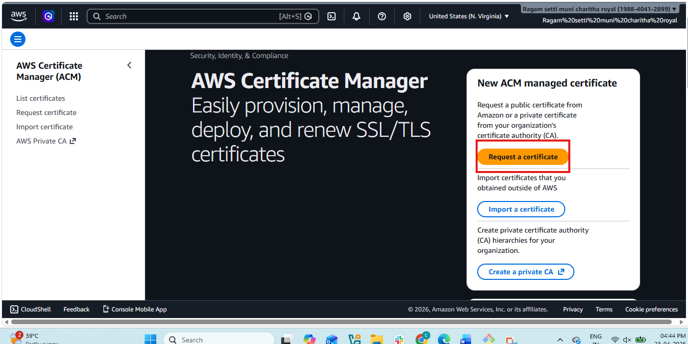
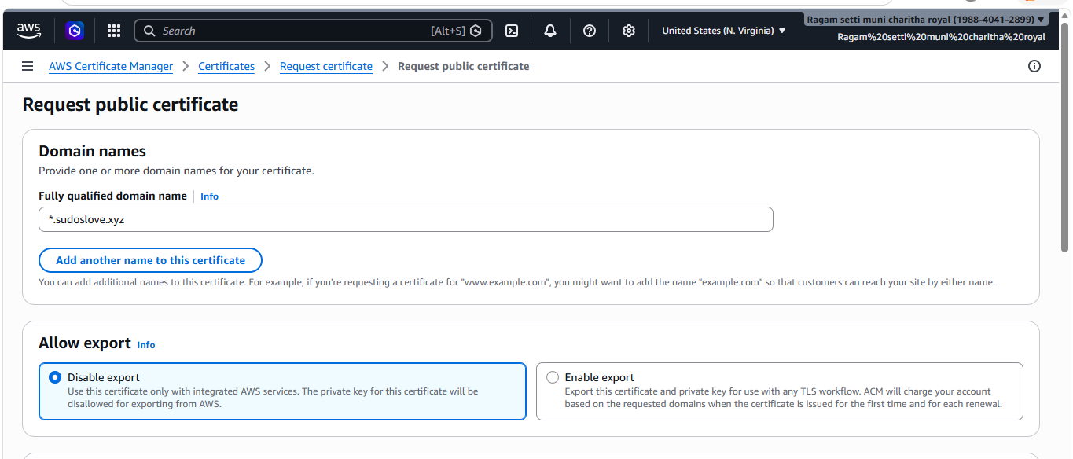
- And certificate status successfully issued.
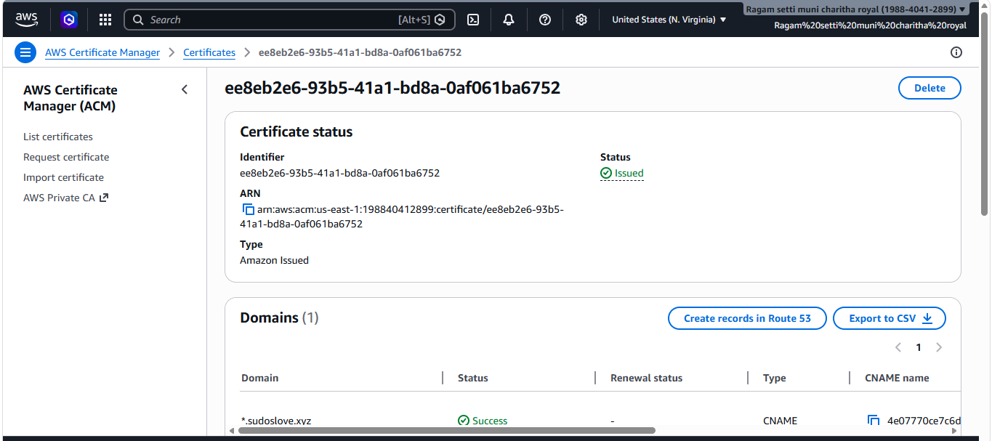

5. Create a Route 53 hosted zone and map the domain with the CDN.
- created a route 53 hosted zone.
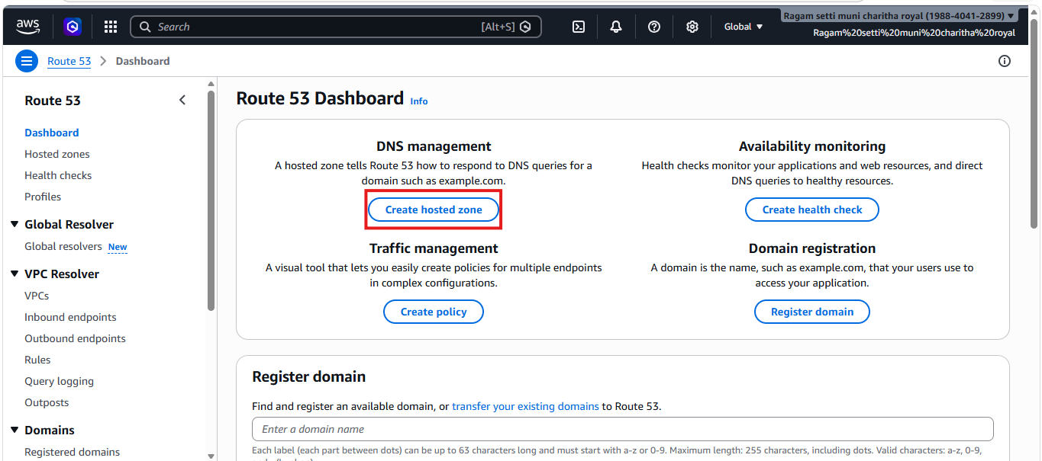
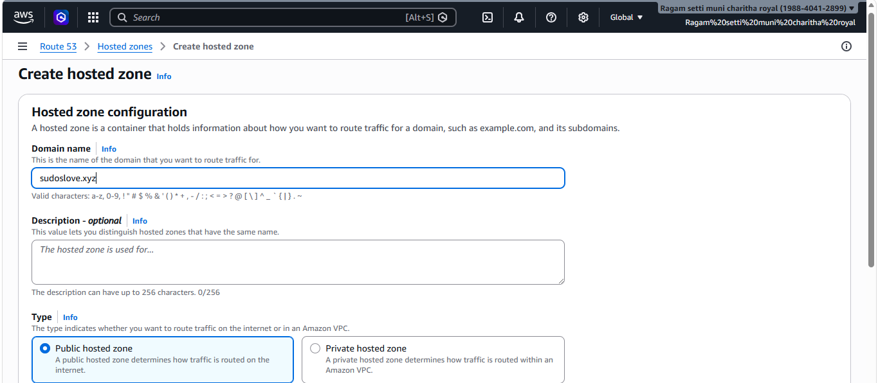
- Created a CloudFront distributions.
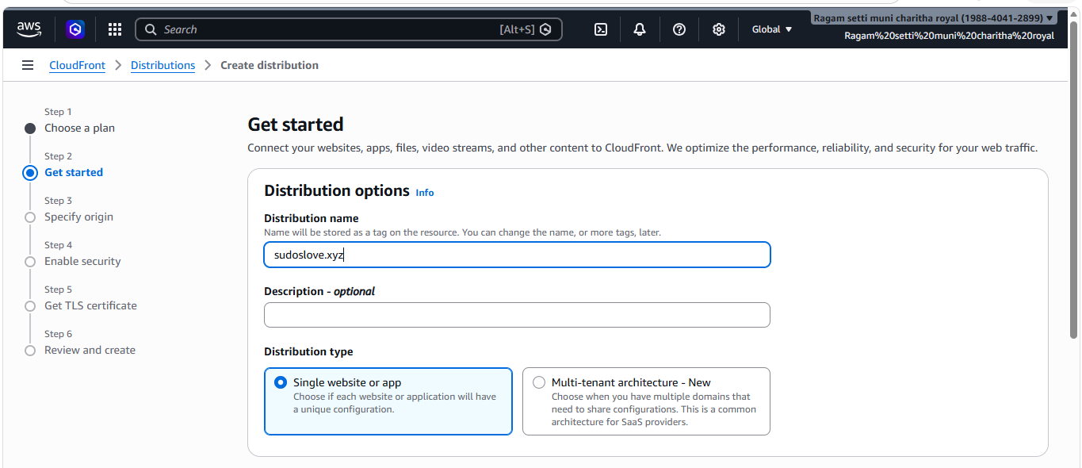
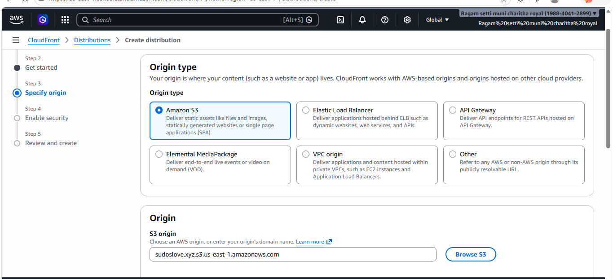
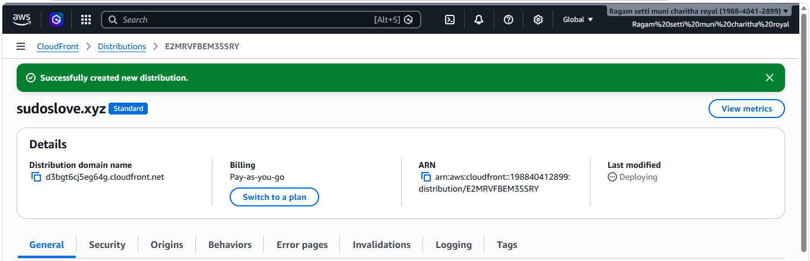
- And added my nameservers in DNS.
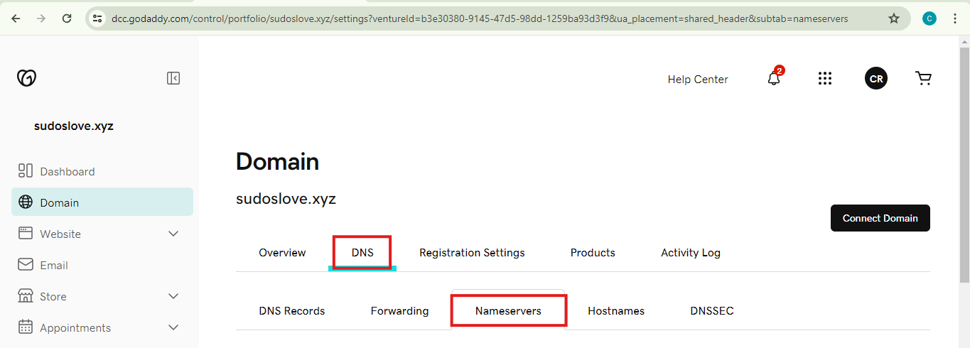
- Copy the nameservers and to the godaddy in the nameservers
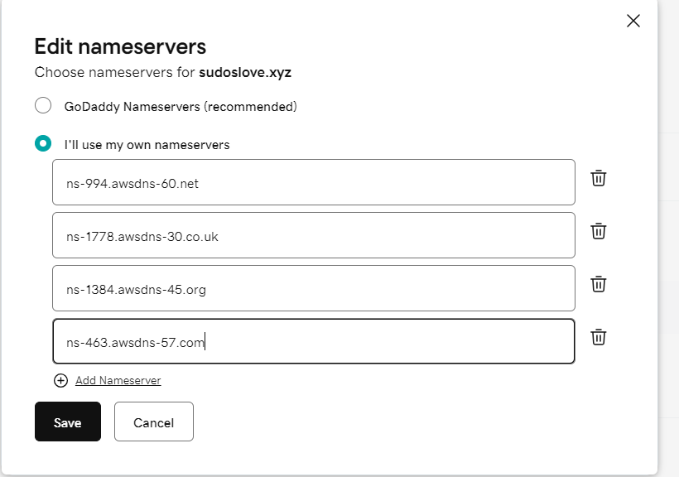
6. Update the index.html in the S3 bucket and ensure the updated file is accessible using the domain name.

- Added a domain and gave that url with my file name it worked.

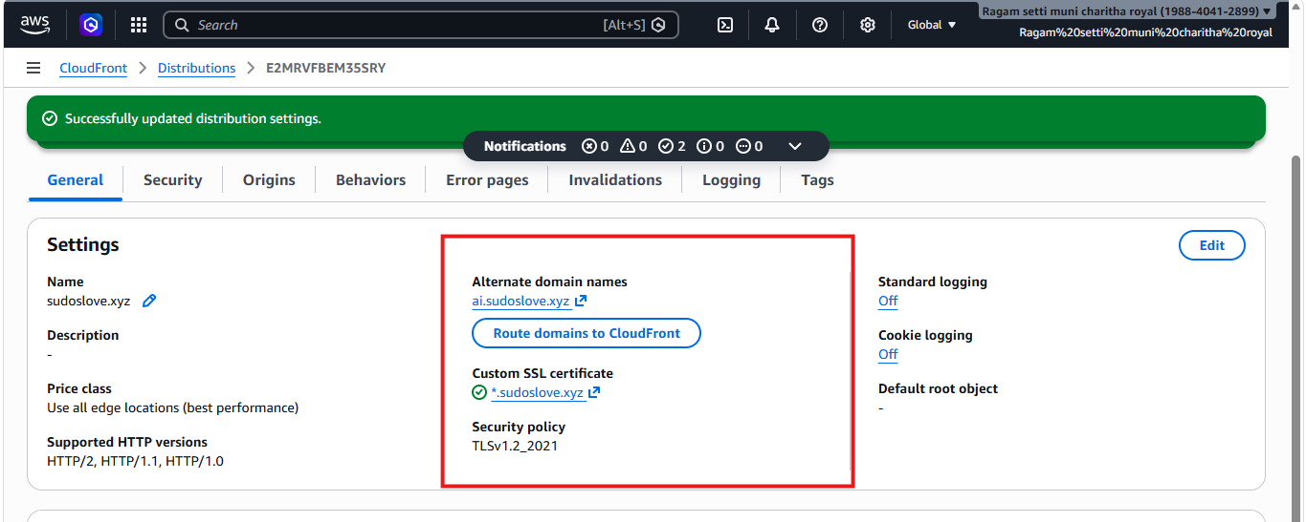
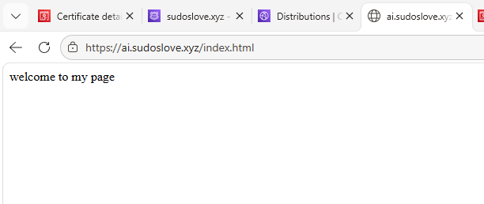
7. Share the domain name in Slack to test the connectivity.
ai.sudoslove.xyz/index.html

